Open the course admin gear and click on More….
Choose Add a new badge.

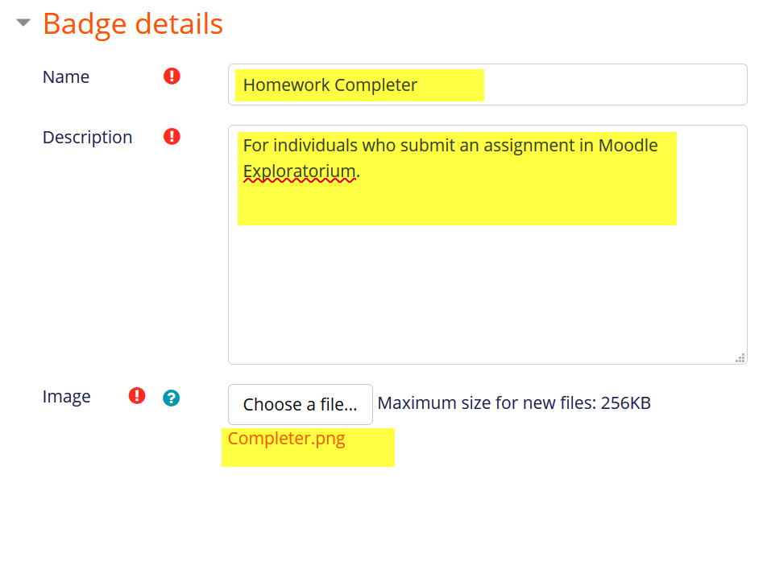
Enter name and description for the badge for your reference.
Upload a file – 100 x 100 pixels – in the image file picker.
Update issuer information, if needed.
Click on create badge.

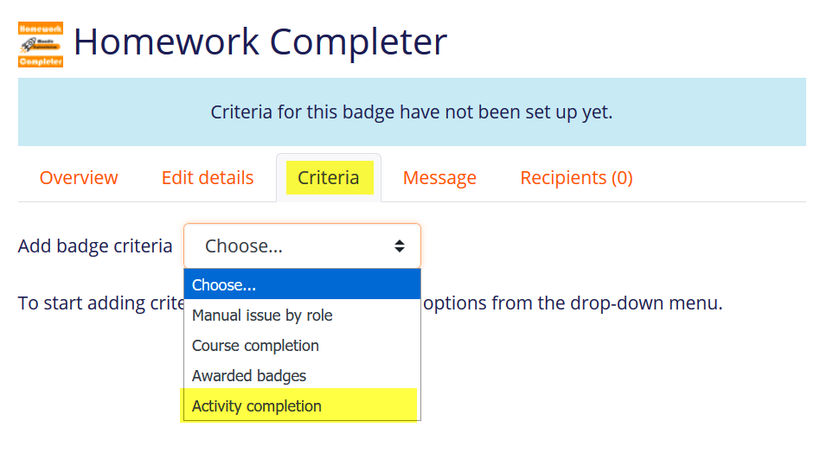
Select the type of criteria for earning the badge, in this case Activity completion and press Enter.

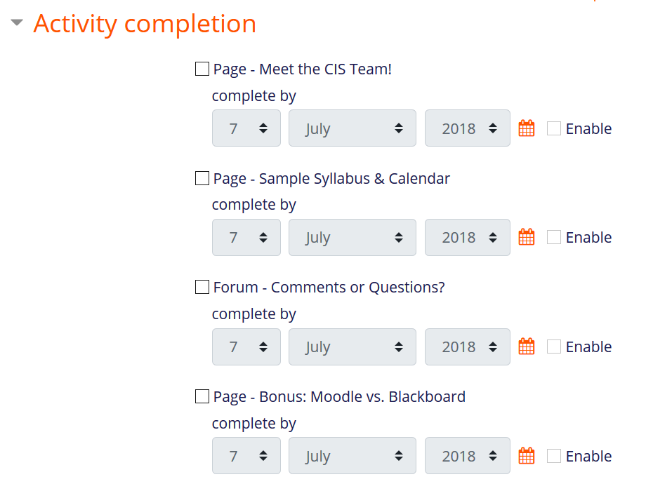
A list of activities that have completion settings enabled will be displayed. Choose the activities that you want to reward.
TIP: Before you take this step, review the items that you intend to include and verify that completion means what you think it means!

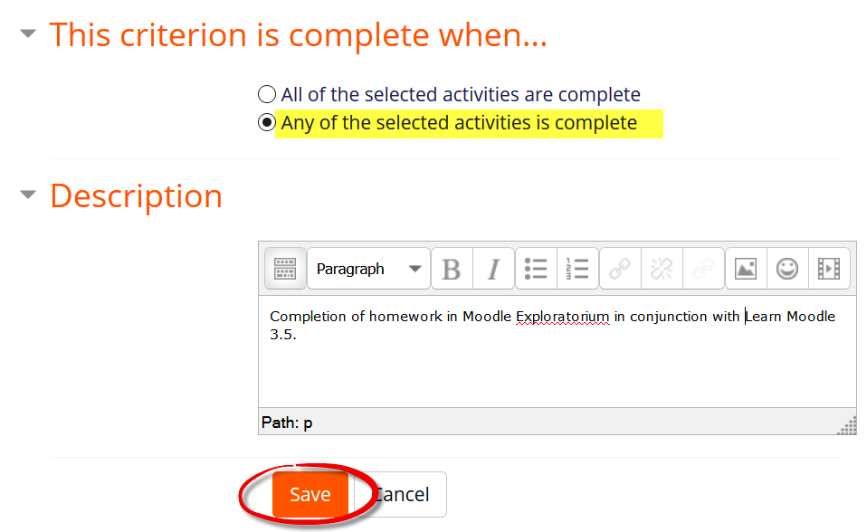
Then indicate if all or some of the activities must be completed to earn the badge.
Add a description of the badge which will appear with the badge.

Save.

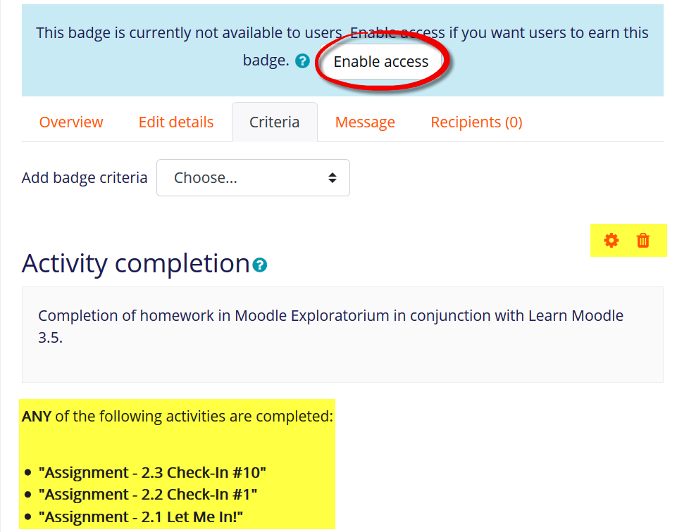
Verify that the badge settings meet your needs and click on Enable access.
Note that you can edit or delete the settings you have made so far.

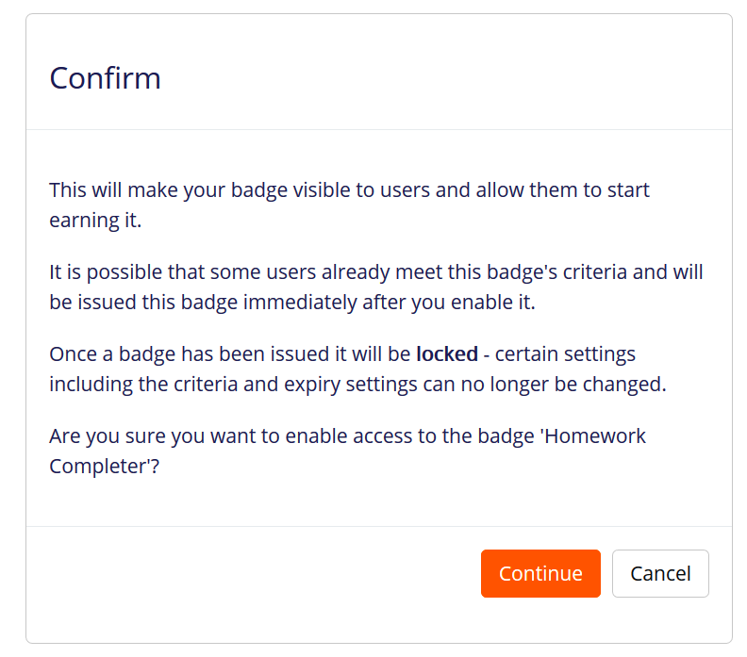
Click on Continue to confirm awarding of the badge.

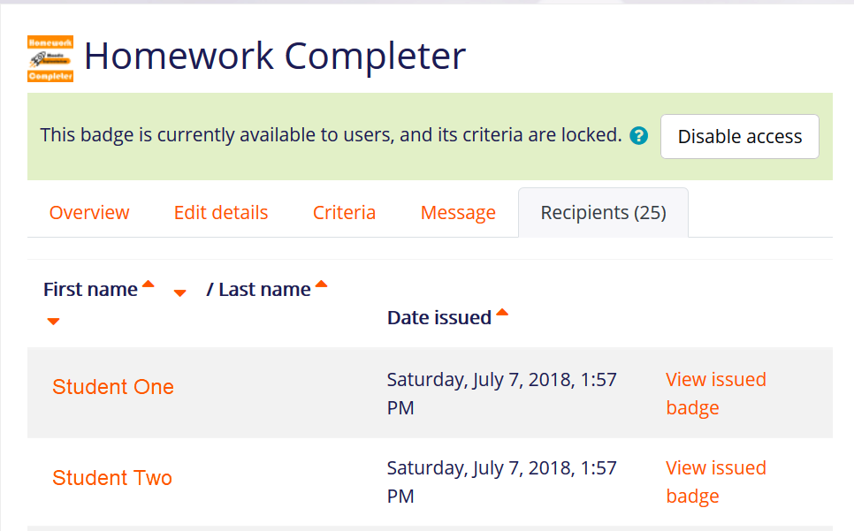
Those who have already earned the badge (if any) will be displayed on the recipients tab.

